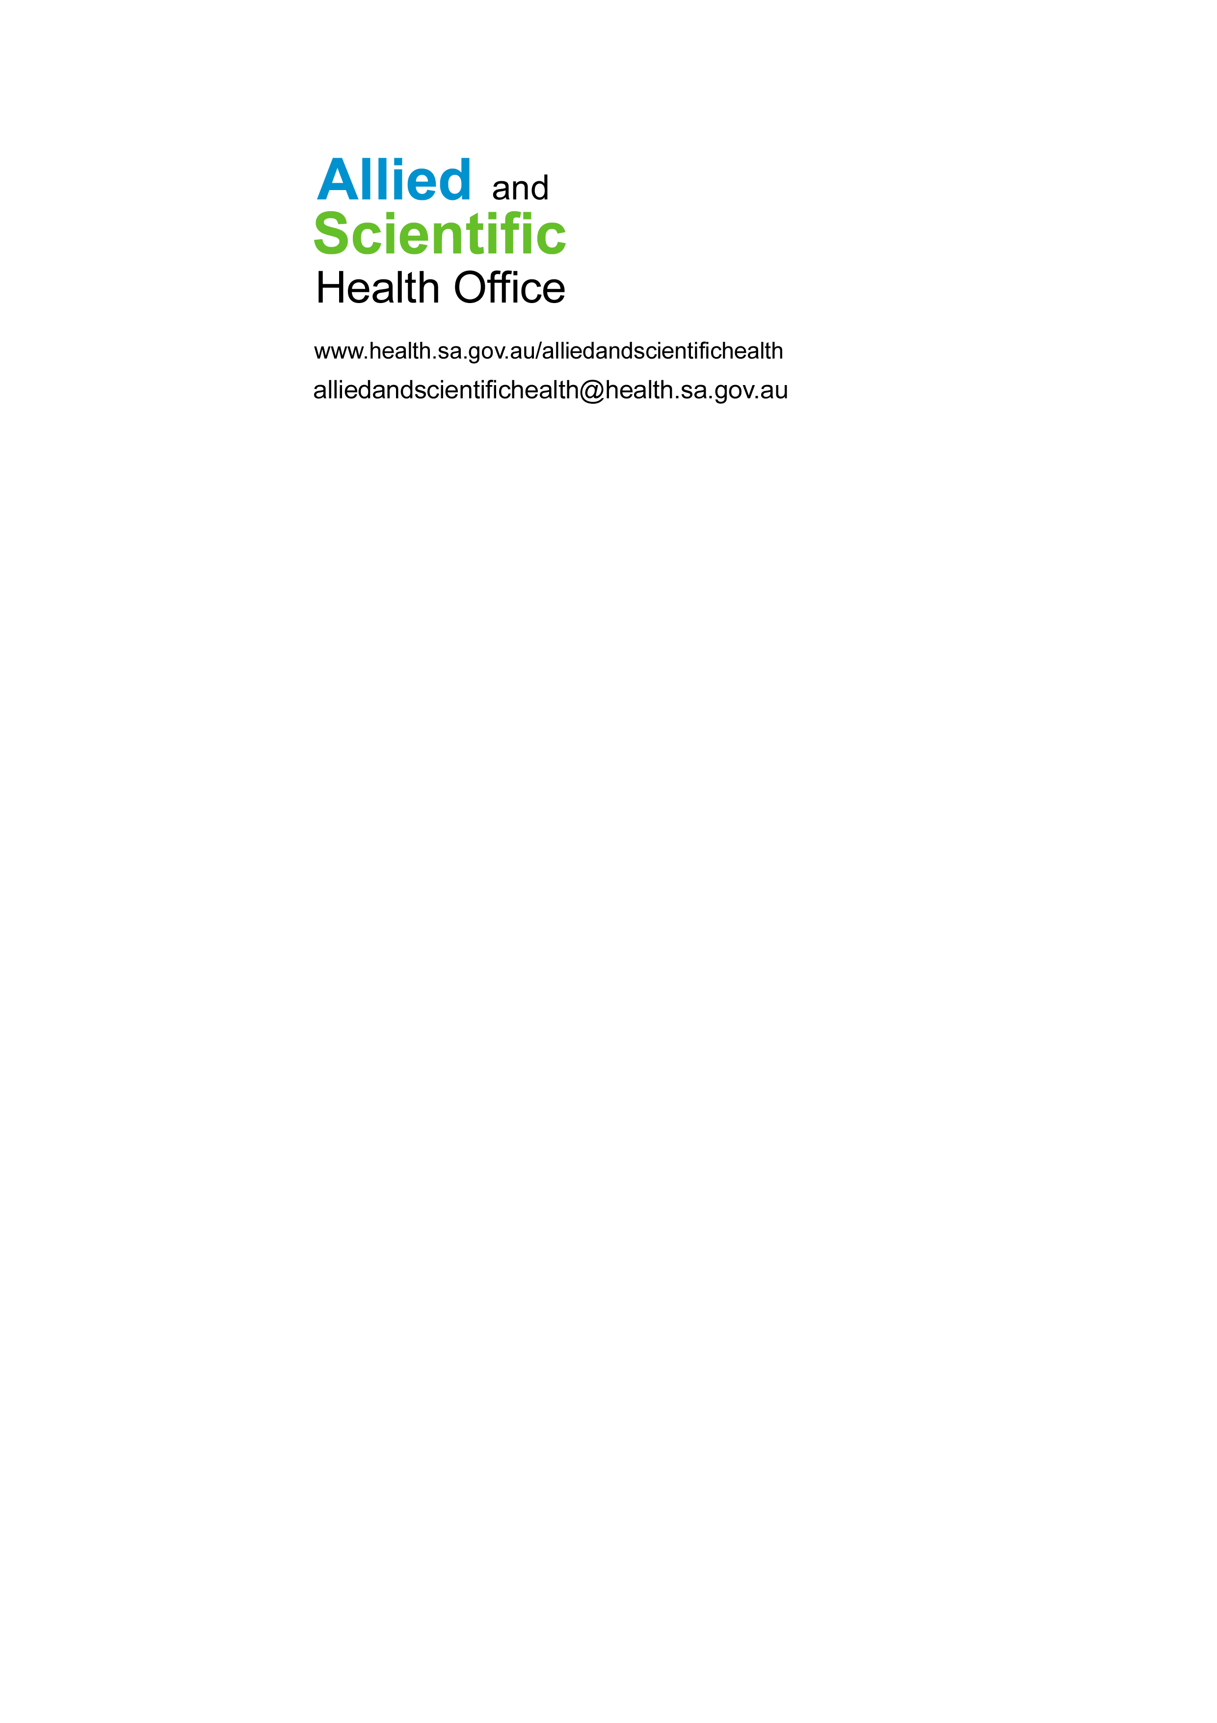

**PROFESSIONAL SUPERVISION NOTES**

**Date:**

**Present:**

**Apologies:**

|  |  |  |  |
| --- | --- | --- | --- |
| **Topic(s)** | **Discussion** | | **Agreed action** |
|  |  | |  |
| ***Next session preparation*** | | | |
| **Agenda items for next session** | | **Preparation required** | |
|  | |  | |

**Sign off:**

|  |  |  |  |
| --- | --- | --- | --- |
| **Signature** |  | **Date** |  |
| **Signature** |  | **Date** |  |

# 