

South Australian Public Health (Legionella) Regulations 2013

Cooling Water System - Alternative Maintenance Program
Application Form

SITE DETAILS

Registered Business Name
ABN_______________________________________________________________________________
Address __________________________________________________________________________________
__________________________________________________________________________________
Trading Name of Premises
Site (Street) Address

Postal Address

Business Contact Phone
Local Council Area
Description of Business Activities

Business Operating Hours
Total Number of Cooling Towers on the Site

Contact person for this application
Name
Position Title
Business Contact Phone _______________________ Mobile

Is the cooling water system registered with the local council?
Yes (please attach a copy of the completed registration form)
No (registration is a mandatory requirement - or within 1 month of commissioning for new systems)

RATIONALE FOR SEEKING AN APPROVAL

Please detail your reason(s) for seeking an alternative maintenance program.

PROPOSED MAINTENANCE PROGRAM

Please indicate the current maintenance program for the cooling water system.
Section 2.5 of AS/NZS 3666.2
Section 3 of AS/NZS 3666.3
Other, please specify

Please detail your proposed alternative maintenance program for which you seek an approval. Please include details of proposed monitoring and evaluation procedures, and any additional risk management strategies (e.g. system performance monitoring; microbial control & testing; additional water treatment & disinfection measures). Please attach additional pages if necessary.

COOLING TOWER DETAILS

Please complete pages 3 and 4 for each cooling tower in the cooling water system for which you seek an approval.

1. Cooling Water System Details

Application of Cooling Water System
Air Handling
Process Cooling, please specify
Other, please specify ______________________________________________________________
How many cooling towers are part of this cooling water system?

2. Cooling Tower Details
Make / Brand
Model No.
System Common Name / Identification No. (e.g. system 1; cooling tower 1)

3. Location of Cooling Tower
Roof Ground Plant Room
Other, please specify

4. Frequency of Operation
Continuous
Seasonal (please specify months) ____________________________________________________
Other, please specify ______________________________________________________________

5. Decontamination Procedure
Please indicate the decontamination procedure used for the cooling water system.

Prescribed decontamination procedure set out in Schedule 3, Part 1 of the Guidelines for the Control of Legionella in Manufactured Water Systems in South Australia
An alternative decontamination procedure approved by the Minister (please attach the approval as an appendix to this application)

6. Automatic Biocide Dosing Devices
Is the cooling tower/cooling water system fitted with an automatic biocide dosing device? (compliant with regulation 7 of the South Australian Public Health (Legionella) Regulations 2013)?
Yes; single dual / alternating
No (this is a mandatory requirement)

7. Drift Eliminator

Does this cooling tower have a drift eliminator fitted (compliant with regulation 8 of the South Australian Public Health (Legionella) Regulations 2013)?

Yes
No – this is a mandatory requirement; have you been granted an exemption by the Minister? Yes (please attach) No

8. Water Supply
Please indicate the type of water supply utilised in the operation of this cooling tower.
Reticulated water (mains water)
Recycled Water (please note: you are required to have an approval from the SA Health)
Rainwater
Other, please specify_______________________________________________________________

9. Laboratory Results
Where available, please provide copies of all relevant laboratory testing results for the cooling water system for the previous 12 months, including Legionella and heterotrophic colony counts (also referred to as total bacterial count).
I have attached copies
I do not have copies to attach

10. Other Records / Reports
Please attach copies of any additional relevant documents which may assist in processing your application (e.g. system servicing/inspection reports and maintenance records).
I have attached copies
I do not have copies to attach

SYSTEM AND SITE PLANS

On the following pages you will need to provide plans of the cooling water system and the site. You may do this by means of existing plans/schematics, drawings or by utilising imaging or photographic applications as appropriate (e.g. Google Maps™ etc). If you are drawing plans of the system or site, please use the symbols provided in the key below to assist with this task.

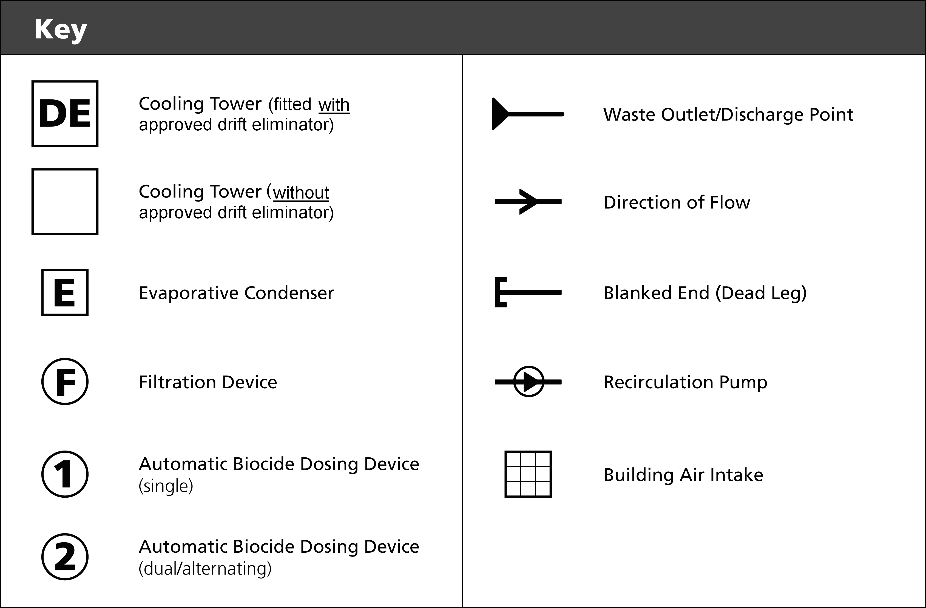

PLAN OF COOLING WATER SYSTEM

Please draw (using the symbols on page 5) or provide a plan which identifies all major components of the cooling water system for which you seek an approval. Please attach additional pages if necessary.

Please Note: Under the Regulations, ‘major components’ of a high risk manufactured water system includes cooling towers, condensers, filtration devices, automatic biocide dosing devices, drift eliminators, water inlets, waste outlets and discharge points, and water storage facilities.

SITE PLAN

Please draw (using the symbols on page 5) or provide a site plan identifying the location of all cooling tower(s), including those in other systems. You must also provide details of the site layout, including proximity of cooling tower(s) to building air intakes, location of any neighbouring schools, health care or aged care facilities and any other relevant information. Please attach additional pages if necessary.

DECLARATION BY APPLICANT / OWNER

I supply the following details with my application:

Copy of completed registration form (containing business details, operation/maintenance contacts etc)

Site & cooling tower details

Proposed alternative maintenance program

Laboratory results (where available)
Other records / reports
System plan, showing major components (with attachment(s) where necessary)
Site plan (with attachment(s) where necessary)

I understand that SA Health may require further details if necessary, and that failure to supply all the details referred to in this application form and any additional information requested by SA Health may delay or prevent the processing of this application

I declare that the contents of this application are true, complete and to the best of my knowledge in every particular. I have not made a false or misleading statement in a material particular (whether by the inclusion or omission of any particular) in any information provided in the content of this application.

NAME: ________________________________________________________________________________
POSITION: _____________________________ COMPANY: _____________________________________
ADDRESS: ____________________________________________________________________________
______________________________________________________________________________________
SIGNATURE: _______________________________________________ DATE: _______/______/_______

APPLICATION & PAYMENT DETAILS

Please refer to the following website for current fees:

http://www.sahealth.sa.gov.au/legionella

Please send your application to:

Health Protection Programs
SA Health
PO Box 6
RUNDLE MALL SA 5000
Phone: (08) 8226 7100
Email: legionella@sa.gov.au

After submitting your application, you will be contacted to arrange payment of the application fee.
Assessment of your application will commence after the fee has been paid.

For further information, please contact Health Protection Programs.

