

South Australian Public Health (Legionella) Regulations 2013

Warm Water System – Alternative Decontamination Procedure
Application Form

SITE DETAILS

Registered Business Name
ABN_______________________________________________________________________________
Address __________________________________________________________________________________
__________________________________________________________________________________
Trading Name of Premises
Site (Street) Address

Postal Address

Business Contact Phone
Local Council Area
Description of Business Activities

Business Operating Hours

Contact person for this application
Name
Position Title
Business Contact Phone _______________________ Mobile

Is the warm water system registered with the local council?
Yes (please attach a copy of the completed registration form)
No (registration is a mandatory requirement - within 1 month of commissioning for new systems)

RATIONALE FOR SEEKING AN APPROVAL

Please detail your reason(s) for seeking an alternative decontamination procedure.

PROPOSED DECONTAMINATION PROCEDURE

Please detail your proposed alternative decontamination procedure for which you seek an approval, including methodology, biocide (type and concentration) and/or temperature/time information, contact time and monitoring and evaluation procedures. Please attach additional pages if necessary.

WARM WATER SYSTEM DETAILS

Please Note: You must complete a separate application form for each warm water system for which you are seeking an approval.

1. Water Heating Device
Make / Brand of System
Model No.
System Common Name / Identification No. (e.g. Floor 1; Warm Water System 1)

Source of Water Heating Gas Electric
Other, please specify
Water Storage or Instantaneous? Storage Instant

2. Temperature Control Devices
Does the system have any temperature control devices fitted (e.g. thermostatic mixing valves/tempering valves)?
Yes, please indicate type(s) and number of devices

No

3. Areas Serviced by System
Please indicate the areas and type and number of outlets serviced by the warm water system (e.g. ground floor bathrooms - 4 showers, 8 basins).

4. Water Supply
Please indicate the type of water supply utilised in the operation of this warm water system.
Reticulated water (mains water)
Recycled Water (please note: you are required to have an approval from SA Health)
Rainwater
Other, please specify_______________________________________________________________

5. Laboratory Results
Where available, please provide copies of all relevant laboratory testing results for the warm water system for the previous 12 months, including Legionella and heterotrophic colony counts (also referred to as total bacterial count).
I have attached copies
I do not have copies to attach

6. Current Decontamination Procedure
Please indicate the decontamination procedure currently in place for the warm water system.

Prescribed decontamination procedure set out in Schedule 3, Part 2 of the Guidelines for the Control of Legionella in Manufactured Water Systems in South Australia
Other, please specify

7. Other records / reports
Please attach copies of any additional relevant documents which may assist in processing your application (e.g. system servicing reports and maintenance records).

I have attached copies
I do not have copies to attach

SYSTEM AND SITE PLANS

On the following pages you will need to provide plans of the warm water system and the site. You may do this by means of existing plans/schematics or by providing a drawing. If you are drawing plans of the system or site, please use the symbols provided in the key below to assist with this task (please note that you will need to print this form and provide your drawing in colour in order to show cold, warm and hot pipe work, outlets and direction of flow).

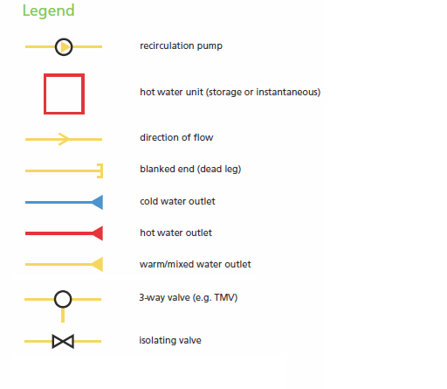

PLAN OF WARM WATER SYSTEM

Please draw (using the symbols on page 4) or provide a plan identifying all major components of the warm water system for which you seek an approval (including cold, hot and warm pipe work, direction of flow, water storage and heating devices and temperature control devices such as thermostatic mixing valves and tempering valves, if fitted). Please attach additional pages if necessary.

SITE PLAN

Please draw or provide a plan identifying the location of the warm water system on the premises, including all areas serviced by the system. Where necessary, attach additional pages.

DECLARATION BY APPLICANT / OWNER

I supply the following details with my application:

Site & system details

Copy of completed registration form (containing business details, operation/maintenance contacts etc)

Proposed alternative decontamination procedure

Laboratory results (where available)
Other records / reports
Plan of major system components (with attachment(s) where necessary)
Site plan (with attachment(s) where necessary)

I understand that SA Health may require further details if necessary, and that failure to supply all the details referred to in this application form and any additional information requested by SA Health may delay or prevent processing of this application

I declare that the contents of this application are true, complete and to the best of my knowledge in every particular. I have not made a false or misleading statement in a material particular (whether by the inclusion or omission of any particular) in any information provided in the content of this application.

NAME: ________________________________________________________________________________
POSITION: _____________________________ COMPANY: _____________________________________
ADDRESS: ____________________________________________________________________________
______________________________________________________________________________________
SIGNATURE: _______________________________________________ DATE: _______/______/_______

APPLICATION & PAYMENT DETAILS

Please refer to the following website for current fees:

http://www.sahealth.sa.gov.au/legionella

Please send your application to:

Health Protection Programs
SA Health
PO Box 6
RUNDLE MALL SA 5000
Phone: (08) 8226 7100
Email: legionella@sa.gov.au

After submitting your application, you will be contacted to arrange payment of the application fee.
Assessment of your application will commence after the fee has been paid.

For further information, please contact Health Protection Programs.

